

**Dhirubhai Ambani Institute of Information and Communication Technology**

**A**

**Project Report**

**On**

**“Online Herbs and Fruits Shopping”**

**Under**

**IT-632 Software Engineering**

**[ WINTER SEMESTER : 2022 ]**

**Software Requirements Specification**

For

**ALL HEAL**

**| Online Herbs & Fruits Shopping |**

Faculty Guide: Prof. Saurabh Tiwari

Mentor: Sameeksha Jain

**Group ID: 11**

|  |  |  |
| --- | --- | --- |
| **ID** | **Name** | **Email ID** |
| 202112006 | Sarthak Mehra | 202112006@daiict.ac.in |
| 202112025 | Kabir Kanjani | 202112025@daiict.ac.in |
| 202112027 | Lakshay Malik | 202112027@daiict.ac.in |
| 202112033 | Sanjana Shah | 202112033@daiict.ac.in |
| 202112035 | Krisha Bhataria | 202112035@daiict.ac.in |
| 202112036 | Miraj Mahant | 202112036@daiict.ac.in |
| 202112037 | Renishkumar Gadhiya | 202112037@daiict.ac.in |
| 202112045 | Harshil Modi | 202112045@daiict.ac.in |
| 202112046 | Shreya Kumawat | 202112046@daiict.ac.in |
| 202112103 | Jay Prajapati | 202112103@daiict.ac.in |
| 202112108 | Jaykumar Bhatt | 202112108@daiict.ac.in |



**Introduction**

The “ALL HEAL“ | Online Herbs & Fruits Selling Store | has been developed to overcome the issues existing in practicing manual system. This webapp will be supportive to reduce or even overcome hardships faced by the user following existing systems. Also, the system is designed to carry out certain operations in an effective manner.

The application is proved to be user friendly as no formal knowledge is required to use it and by various means it also provides error messages if the user mistakenly enters invalid data. Thus, leading it towards error free and reliable way of fast management.

**Purpose**

ALL HEAL’s core motive is to automate the prevailing manual store visit by an interactive yet user friendly webapp in an artistic merging of Ayurveda with touch of technology.

ALL HEAL will not only help the consumers to purchase herbs and fruits but it also aims to provide information regarding herbs and their benefits in our fast-moving world where merely any person cares about their own life routine, the system aims to help the users in curing disease by giving the list of fruits, vegetables and herbs that the user should consume in order to get rid of disease. Here products are easily available with reasonable price. For kitchen garden small plants and are herbs are also available.

It helps to manage the details of the Products, Product Category, Product Type, Customers, Hospitals and other related information.

**Scope**

* The scope for this system is to improve the way of getting herbs, fruits in reasonable cost.
* To give a well-organize platform for managing all its work & get connected with customer etc.
* To provide up-to-date information corresponding to different categories like:
* Get herbs and fruits easily.
* Get quality and fresh product.
* Offers for consumers.
* Get relevant information regarding treatment of disease corresponding to their specific hospitals.
* Provide relevant information about the products.
* Fast delivery.

**Future Enhancements**

* Mobile-friendliness
* Live chat

**Stakeholders: -**

* **Admin:**

Admin handles the whole “Online Herbs Shopping Project” application.

Admin handles the blogs / articles providing information regarding herbs.

* **Seller:**

Seller sells product. Seller can be any person/user/farmer.

Seller supplies fruits, vegetables and herbs for the ALL HEAL.

* **Customer:**

Customer will have access to their cart, they can purchase the products and can even get regarding herbs, fruits and diseases.

**Process Model**

The Incremental Model, also referred as the successive version model, is a widely adopted model of software development process where the software requirements are divided into multiple stand-alone increments in the SDLC. Each increment is treated as a sub-project and goes through all phases of the SDLC incremental model. This sounds similar to an iterative model. However, this model is an enhancement to the iterative model and due to this, the incremental model is also called the Iterative Enhancement Model.

In the incremental model, instead of making one huge leap, we achieve our goals in small steps.

As part of the Incremental model, each increment passes through **four phases**. Every new release of the module adds functionality to the previous release module. The process continues until all the intended functionality has been implemented and the complete system is developed.

**Phases: -**

1. Requirements,
2. Design and Development,
3. Testing,
4. Implementation

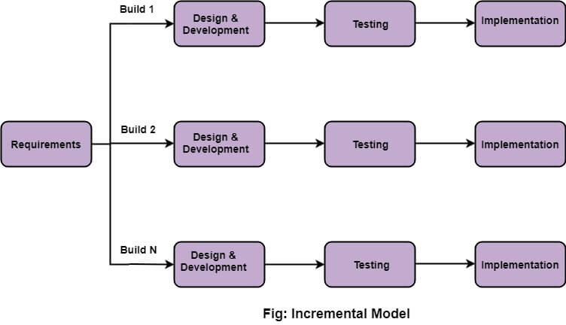

Here, in this system we will follow the ***Parallel Development Model***:

This incremental model involves the simultaneous development of different sub-systems.

As long as sufficient resources are available, it can decrease the amount of time needed for the development process, i.e., TTM (Time to Market).

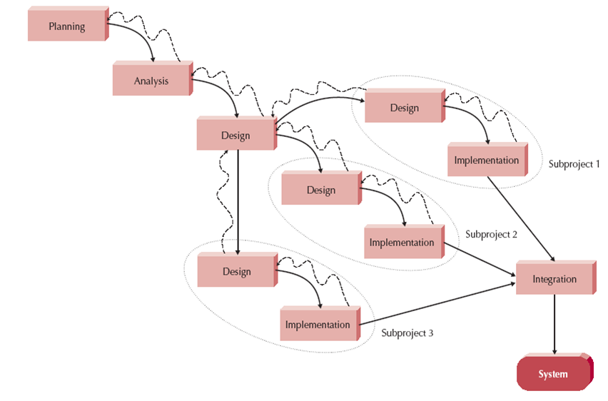

Most often, Increment Models are used when:

* Requirements are clearly specified, understood, and are known up-front. Certain requirements, however, require time.
* There is a requirement to release the product early or get it to the market early.
* Engineering team lacks the required skill set, or the resources are unavailable.
* Product-based companies develop their own products.
* New technologies are used.
* High risk goals or features are involved.
* Projects have long development schedules.

**Advantages:**

Incremental models offer a number of benefits, some of which are highlighted below:

* Through incremental development, 100% of the software objectives and requirements are met.
* A good option for dealing with cost and flexibility is the incremental model. Scope and requirements can be altered at any time throughout development.
* Verifying and debugging this model is easy and straightforward.
* This model enables us to produce working software earlier and more rapidly during product development. As a result of dividing the work, completion time can be reduced.
* This model permits the client to respond to and provide feedback on every build.
* Identifying errors becomes easy with incremental models. This simplifies risk management since risky pieces are identified and dealt with during iterations.
* The product’s most important and useful functional capabilities can be identified at an early stage of the development process.

**Functional Requirements**

* **Registration**: There are three types of registered accounts in the system: one will be an Admin, who is responsible for adding blocking/unblocking members; a Buyer, who can buy, search products and also search for hospitals; and last one is seller who can add products for selling.
* **Login:** Only the authorizedUsers can log in using their respective credentials.
* **Admin:**

1. **Manage Product**: Admin will verify the product which will be added by the seller and can also remove them.
2. **Manage Users:** Admin will verify the users that gets registered & seller will be verified by GST number.
3. **Manage Delivery Status**: Admin will update the delivery status of buyer who have placed order for products.
4. **Manage Refund of products:** Admin will manage the return of product returned by buyer and manages the payment refund.
5. **Reports:** Admin can generate various reports.

* **Buyer:**

1. **Edit Profile:** Buyer can edit his/her personal details.
2. **Search Product:** Buyer can search particular product in two ways: one with the name of product and other by disease name.
3. **Search Hospital:** Buyer can search for nearby hospital according to the disease.
4. **Add to Cart:** Buyer can add multiple products to cart to buy multiple products at a time.
5. **Place Order:** Buyer will can place order for single product by clicking directly on Buy Now and can also place order for multiple products.
6. **Make Payment:** Buyer can make payment after placing order.
7. **Return Order:** Buyer can return the order placed.
8. **Feedback:** Buyer can give feedback for the products used.
9. **Order History:** Buyer can view past orders placed.

* **Seller:**

1. **Edit Profile:** Seller can edit his/her personal details.
2. **Manage Product:** Seller can add, edit and delete products to kept for selling.
3. **Manage Offers:** Seller can add, edit and delete offers kept on products to be given to buyer.
4. **Manage Stock:** Seller can manage product stock and can disable product if out of stock.
5. **Manage Orders:** Seller can verify the order placed by buyer and confirm the order.

* **System:**
  + - 1. System will only allow the registered customers to place order.
      2. System will check for the 10 Day replacement.
      3. System will notify users for delivery status.

**Other Functional Requirements:**

1. Minimum steps to make a purchase.
2. Unique, recognizable design.
3. Relevant, useful content.
4. Payment systems integration.
5. A handy set of filters.

**Non-Functional Requirements:**

1. **Usability:** How easily a user can achieve their target in a single page visit
2. **Security:** System should be secure and should not leak sensitive data of users.
3. **Performance:** System should get load as fast as possible & should perform 24*7.
4. **Maintainability**: System is made with low cost and time.
5. **Scalability:** It will define how the website can grow and increase its features and functionality without impacting the performance of your website.

**USE CASE**

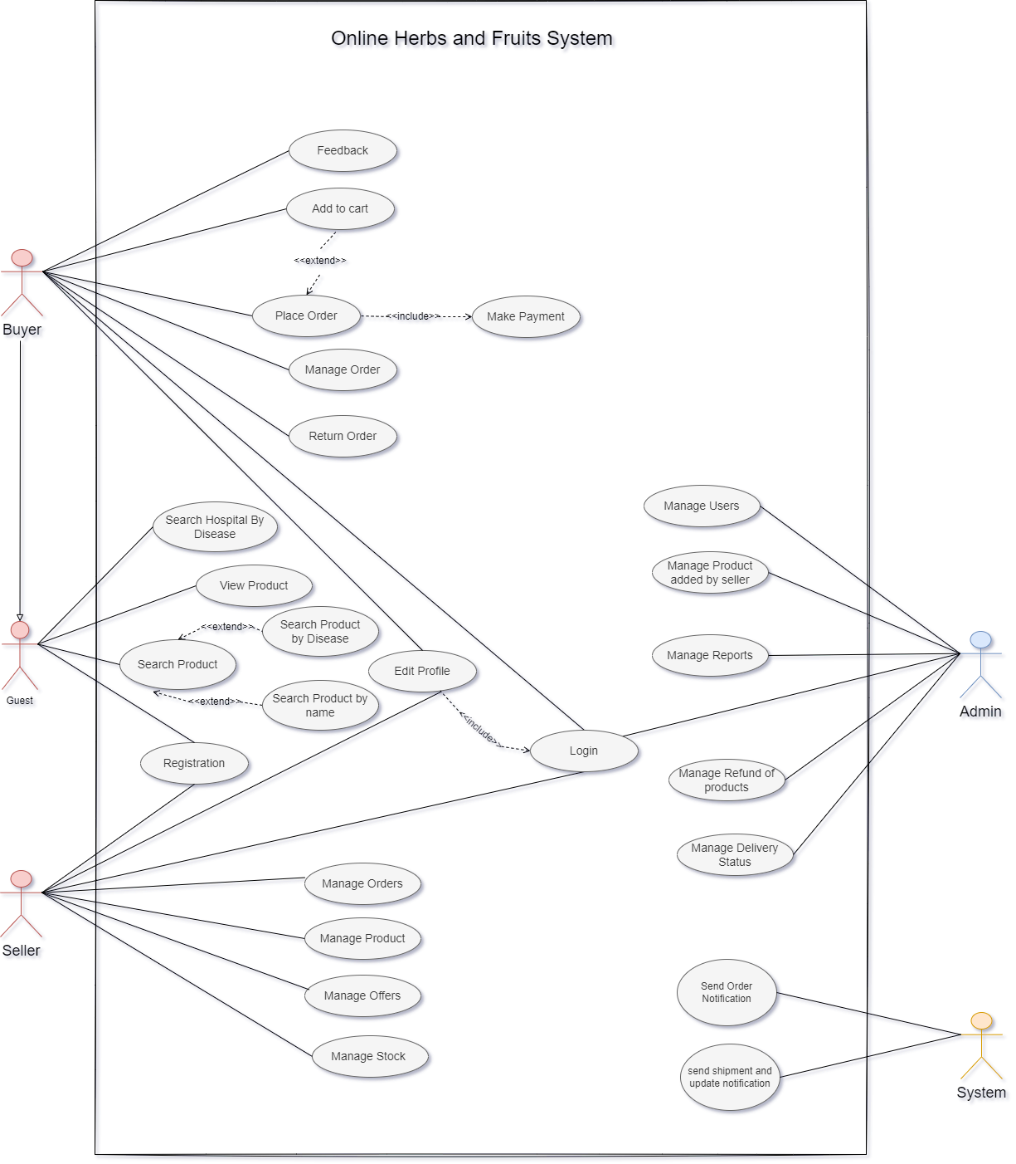

**Output Windows**

Registration Pages:

